
Experiment No. 10
Title: IoT for Smart Cities: Use Cases and Implementation Strategies
Aim: To study the application of IoT for development of urban area with modernized way. Theory: A smart city is a technologically modern urban area that uses different types of electronic methods and sensors to collect specific data. Information gained from that data is used to manage assets, resources and services efficiently; in return, that data is used to improve operations across the city. This includes data collected from citizens, devices, buildings and assets that is processed and analyzed to monitor and manage traffic and transportation systems, power plants, utilities, urban forestry, water supply networks, waste, criminal investigations, information systems, schools, libraries, hospitals, and other community services. Smart cities are defined as smart both in the ways in which their governments harness technology as well as in how they monitor, analyze, plan, and govern the city. In smart cities, the sharing of data is not limited to the city itself but also includes businesses, citizens and other third parties that can benefit from various uses of that data. Sharing data from different systems and sectors creates opportunities for increased understanding and economic benefits. The smart city concept integrates information and communication technology ('ICT'), and various physical devices connected to the Internet of things ('IoT') network to optimize the efficiency of city operations and services and connect to citizens. Smart city technology allows city officials to interact directly with both community and city infrastructure and to monitor what is happening in the city and how the city is evolving. ICT is used to enhance quality, performance and interactivity of urban services, to reduce costs and resource consumption and to increase contact between citizens and government. Smart city applications are developed to manage urban flows and allow for realtime responses. Use Cases Public transport
The data from IoT sensors can help to reveal patterns of how citizens use transport. Public transportation operators can use this data to enhance traveling experience, achieve a higher level of safety and punctuality. To carry out a more sophisticated analysis, smart public transport solutions can combine multiple sources, such as ticket sales and traffic information.
In London, for instance, some train operators predict the loading of train passenger cars on their trips in and out of the city. They combine the data from ticket sales, movement sensors, and CCTV cameras installed along the platform. Analyzing this data, train operators can predict how each car will load up with passengers. When a train comes into a station, train operators encourage passengers to spread along the train to maximize the loading. By maximizing the capacity use, train operators avoid train delays. Street lighting Utilities
IoT-equipped smart cities allow citizens to save money by giving them more control over their home utilities. IoT enables different approaches to smart utilities:

Smart meters & billing
With a network of smart meters, municipalities can provide citizens with cost-effective connectivity to utilities companies’ IT systems. Now, smart connected meters can send data directly to a public utility over a telecom network, providing it with reliable meter readings. Smart metering allows utilities companies to bill accurately for the amount of water, energy and gas consumed by each household.

Revealing consumption patterns
A network of smart meters enables utilities companies to gain greater visibility and see how their customers consume energy and water. With a network of smart meters, utilities companies can monitor demand in real time and redirect resources as necessary or encourage consumers to use less energy or water at times of shortage.

Remote monitoring
IoT smart city solutions can also provide citizens with utility management services. These services allow citizens to use their smart meters to track and control their usage remotely. For instance, a householder can turn off their home central heating using a mobile phone. Additionally, if a problem (e.g., a water leakage) occurs, utilities companies can notify householders and send specialists to fix it. Street lighting
IoT-based smart cities make maintenance and control of street lamps more straightforward and costeffective. Equipping streetlights with sensors and connecting them to a cloud management solution helps to adapt lighting schedule to the lighting zone.
Smart lighting solutions gather data on illuminance, movement of people and vehicles, and combine it with historical and contextual data (e.g., special events, public transport schedule, time of day and year, etc.) and analyze it to improve the lighting schedule. As a result, a smart lighting solution “tells” a streetlight to dim, brighten, switch on or switch off the lights based on the outer conditions.
For instance, when pedestrians cross the road, the lights around the crossings can switch to a brighter setting; when a bus is expected to arrive at a bus stop, the streetlights around it can be automatically set brighter than those further away, etc.

Waste management
Most waste collection operators empty containers according to predefined schedules. This is not a very efficient approach since it leads to the unproductive use of waste containers and unnecessary fuel consumption by waste collecting trucks.
IoT-enabled smart city solutions help to optimize waste collecting schedules by tracking waste levels, as well as providing route optimization and operational analytics.
Each waste container gets a sensor that gathers the data about the level of the waste in a container. Once it is close to a certain threshold, the waste management solution receives a sensor record, processes it, and sends a notification to a truck driver’s mobile app. Thus, the truck driver empties a full container, avoiding emptying half-full ones.

Environment
IoT-driven smart city solutions allow tracking parameters critical for a healthy environment in order to maintain them at an optimal level. For example, to monitor water quality, a city can deploy a network of sensors across the water grid and connect them to a cloud management platform. Sensors measure pH level, the amount of dissolved oxygen and dissolved ions. If leakage occurs and the chemical composition of water changes, the cloud platform triggers an output defined by the users. For example, if a Nitrate (NO3) level exceeds 1 mg/L, a water quality management solution alerts maintenance teams of contamination and automatically creates a case for field workers, who then start fixing the issue.
Another use case is monitoring air quality. For that, a network of sensors is deployed along busy roads and around plants. Sensors gather data on the amount of CO, nitrogen, and sulfur oxides, while the central cloud platform analyzes and visualizes sensor readings, so that platform users can view the map of air quality and use this data to point out areas where air pollution is critical and work out recommendations for citizens. Public safety
For enhancing public safety, IoT-based smart city technologies offer real-time monitoring, analytics, and decision-making tools. Combining data from acoustic sensors and CCTV cameras deployed throughout the city with the data from social media feed and analyzing it, public safety solutions can predict potential crime scenes. This will allow the police to stop potential perpetrators or successfully track them.
For example, more than 90 cities across the United States use a gunshot detection solution. The solution uses connected microphones installed throughout a city. The data from microphones passes over to the cloud platform, which analyzes the sounds and detects a gunshot. The platform measures the time it took for the sound to reach the microphone and estimates the location of the gun. When the gunshot and its location are identified, cloud software alerts the police via a mobile app.

Iterative approach to implementing smart city solutions
The range of smart city applications is highly diverse. What they have in common is the approach to implementation. Whether municipalities plan to automate waste collection or improve street lighting, they should start with the foundation – a basic smart city platform. If a municipality prefers to expand the range of smart city services in the future, it will be possible to upgrade the existing architecture with new tools and technologies without having to rebuild it. Here is a sixstep implementation model to follow for creating an efficient and scalable IoT architecture for a smart city.
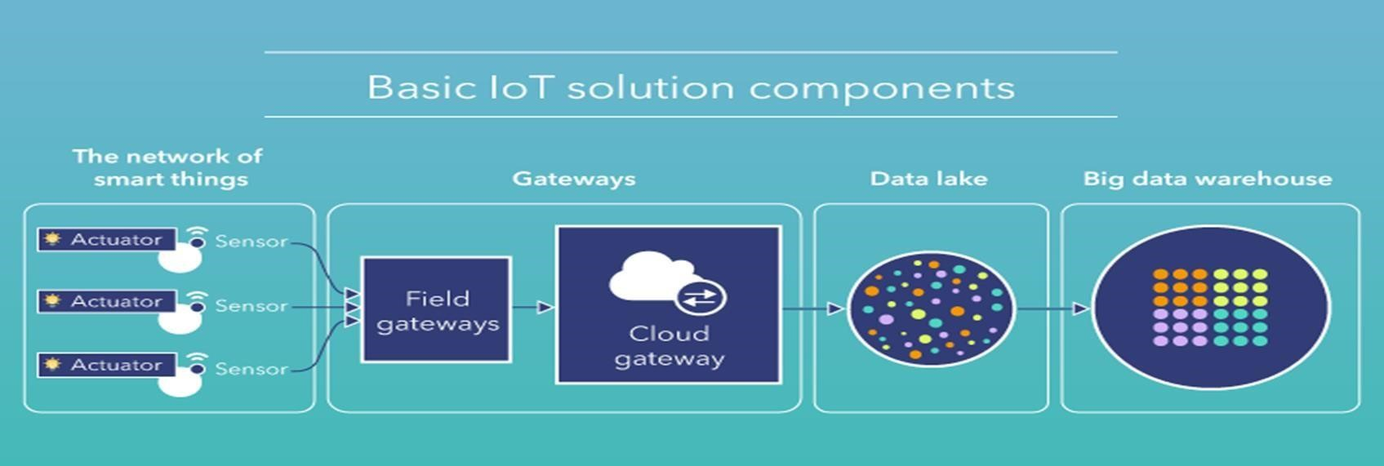

Stage 1: basic IoT-based smart city platform
To be able to scale, smart city implementation should start with designing a basic architecture – it will serve as a springboard for future enhancements and allow adding new services without losing functional performance. A basic IoT solution for smart cities includes four components:

The network of smart things
A smart city – as any IoT system – uses smart things equipped with sensors and actuators. The immediate goal of sensors is to collect data and pass it to a central cloud management platform. Actuators allow devices to act - alter the lights, restrict the flow of water to the pipe with leakage, etc.

Gateways
Any IoT system comprises two parts – a “tangible” part of IoT devices and network nodes and a cloud part. The data cannot simply pass from one part to the other. There must be doors – field gateways. Field gateways facilitate data gathering and compression by preprocessing and filtering data before moving it to the cloud. The cloud gateway ensures secure data transmission between field gateways and the cloud part of a smart city solution. Data lake
The main purpose of a data lake is to store data. Data lakes preserve data in its raw state. When the data is needed for meaningful insights, it’s extracted and passed over to the big data warehouse. Big data warehouse
A big data warehouse is a single data repository. Unlike data lakes, it contains only structured data. Once the value of data has been defined, it’s extracted, transformed and loaded into the big data warehouse. Moreover, it stores contextual information about connected things, e.g., when sensors were installed, as well as the commands sent to devices’ actuators by control applications. Stage 2: Monitoring and basic analytics
With data analytics, it is possible to monitor devices’ environment and set rules for control applications (we cover them at stage 4) to carry out a particular task.
For example, analyzing the data from soil moisture sensors deployed across a smart park, cities can set rules for the electronic valves to close or open based on the identified moisture level. The data collected with sensors can be visualized on a single platform dashboard, allowing users to know the current state of each park zone.

Stage 3: Deep analytics
Processing IoT-generated data, city administrations can go beyond monitoring & basic analytics and identify patterns and hidden correlations in sensor data. Data analytics uses advanced techniques like machine learning (ML) and statistical analysis. ML algorithms analyze historical sensor data stored in the big data warehouse to identify trends and create predictive models based on them. The models are used by control applications that send commands to IoT devices’ actuators. Here is how it applies in practice. Unlike a traditional traffic light that is programmed to display a particular signal for a definite period, a smart traffic light can adapt signal timings to the traffic scenario. ML algorithms are applied to historical sensor data to reveal traffic patterns and adjust signal timings, helping to improve average vehicle speed and avoid congestions.

Stage 4: Smart control
Control applications ensure better automation of smart city objects by sending commands to their actuators.
Basically, they “tell” actuators what to do to solve a particular task. There are rule-based and MLbased control applications. Rules for rule-based control applications are defined manually, while ML-based control applications use models created by ML algorithms. These models are identified based on data analysis; they are tested, approved and regularly updated. Stage 5: Instant interacting with citizens via user applications
Along with the possibility of automated control, there should always be an option for users to influence the behavior of smart city applications (for example, in case of emergency). This task is carried out by user applications.
User applications allow citizens to connect to the central smart city management platform to monitor and control IoT devices, as well as receive notifications and alerts. For example, using GPS data from drivers’ smartphones, a smart traffic management solution identifies a traffic jam. To prevent even bigger congestion, the solution automatically sends a notification to the drivers in the area, encouraging them to take a different route.
At the same time, employees at a traffic control center who use a desktop user app receive a ‘congestion alert.’ To relieve the congestion and re-route part of the traffic, they send a command to the traffic lights’ actuators to alter the signals.
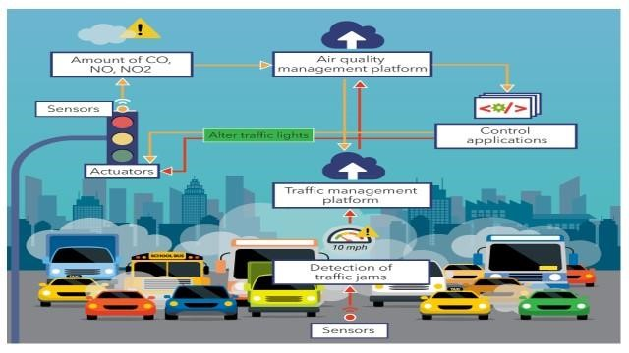

Conclusion:-
IoT helps cities connect and manage multiple infrastructure and public services. From smart lighting and road traffic to connected public transport and waste management – the range of use cases is highly diverse. What they have in common is the outcomes. Applying IoT solutions leads to reduced costs for energy, optimized use of natural resources, safer cities, and a healthier environment.

However, to enjoy these benefits, municipalities should take a consistent approach to design a functional and scalable smart city architecture. Well-designed, it will allow to reduce investments in IoT development and hasten the implementation of smart city solutions, still leaving space for expansion.

